Abdullah Bin Abbas Girls' School
Final worksheet Date:_/5/2015
Second Grade

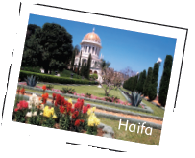
Listen and write:

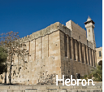
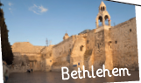
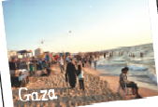

Listen and write:
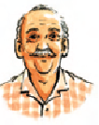
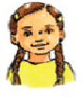
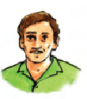
grandmother
dad
mum
grandfather
brother
cousin

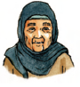
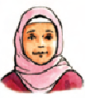
ــــــــــــــــــــــــ ـــــــــــــــــــــ ــــــــــــــــــــ

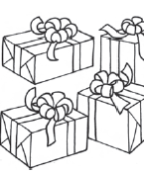
ــــــــــــــــــــــ ــــــــــــــــــــــــ ــــــــــــــــــ
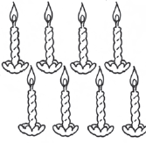
Read and colour:

green candles red presents

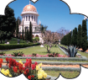
Read and circle:
- She's from Jerusalem / Haifa .
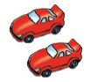
- These cars is / are fast.
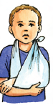

- He feels happy / sad .
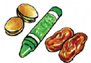
- Crayon is between / on nuts and dates.

Read and write:
- small. / car / This / is__________________________
- reading / We / like__________________________
Find and write :
shirt | town | mountain | pyjamas | mouse | swimming
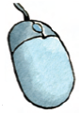
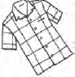
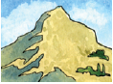

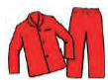
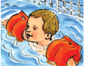
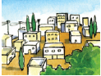

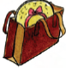
Match:
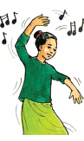
- He likes playing with friends.
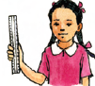
- She's from Jerusalem .
- She has a ruler .
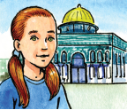
- She's dancing .
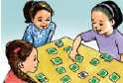
- a keyboard .
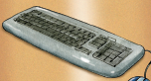
- The hat is in the bag.

Circle and Write :
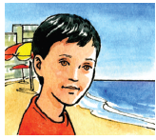
This is my cousin / mother .
---------------------------------------------
He has black / blonde hair .
--------------------------------------------
He's from Nablus / Gaza .
------------------------------------------------
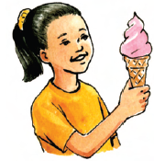
Complete:
How do you feel ?
I / feel / happy /sad
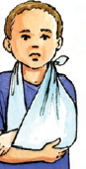
--------------------
-------------------

Complete:
A ___ ___ D ___ ___ G .
___ o ____ ____ r ____ ____ u ___ ____ x .
10 ____ ____ 13 ___ _____ _____ 17 ____ ____ 20.

Write:
His pyjamas are blue and brown .

