English
Name: final exam 2nd grade:

Question number one: choose the meaning: ( 10 marks)
Earache / ruler / mosque / fox / bear / stomachache / headache / toothache /park / grandparents

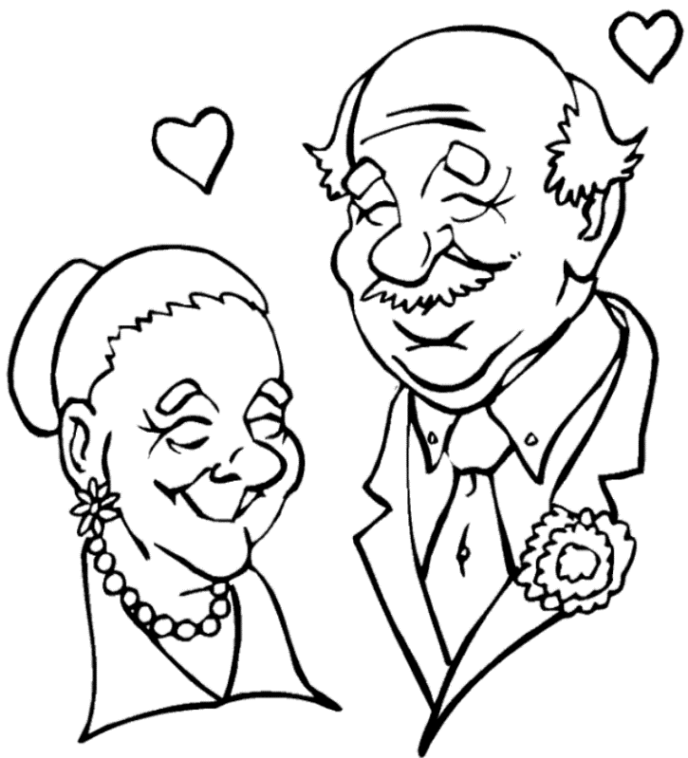
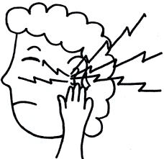
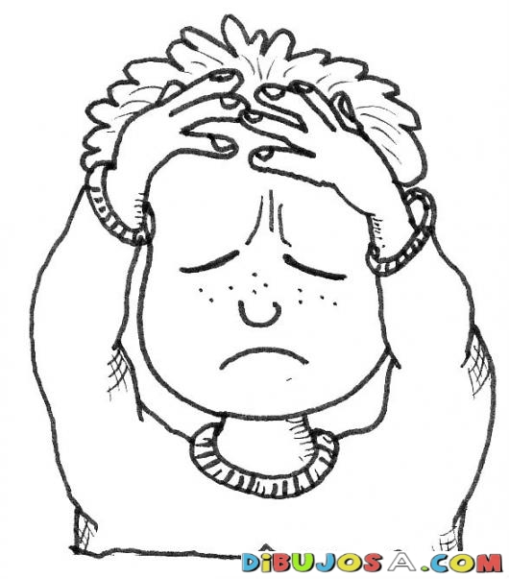
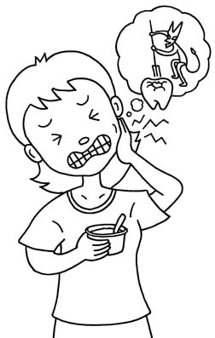


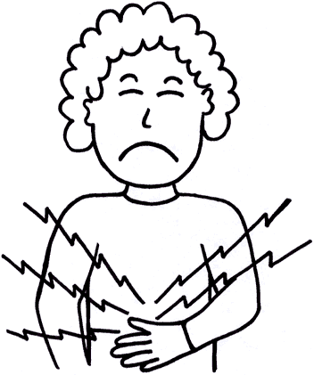
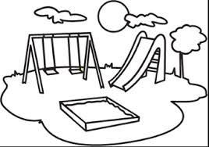
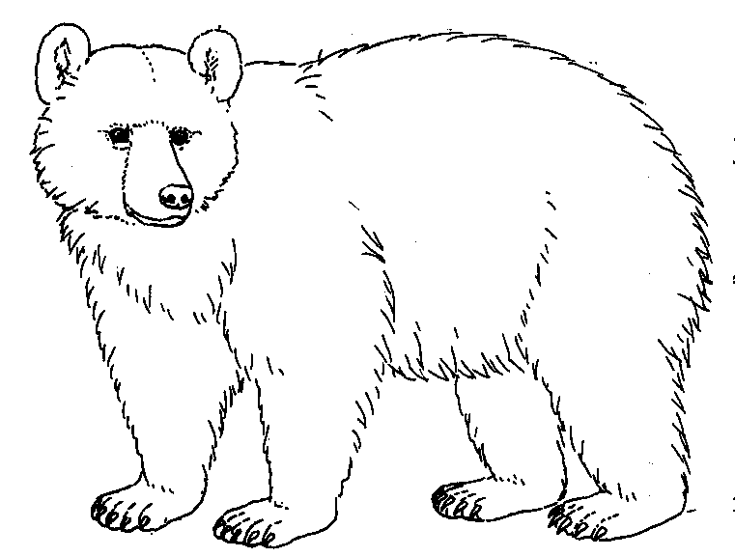
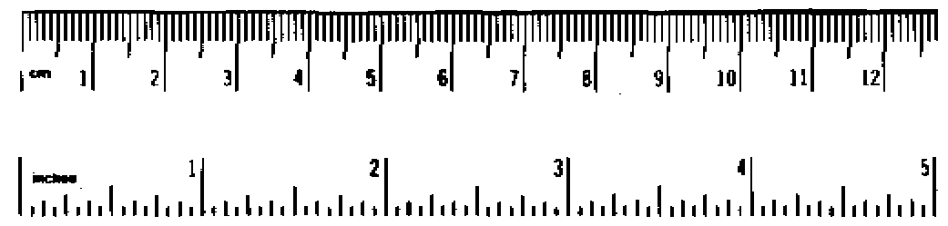
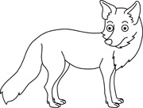

Question number two: read and complete ( 10 marks)
Tuesday / Thursday / Wednesday / Friday / Monday

Question number three: ask, answer and circle: ( 5 marks)
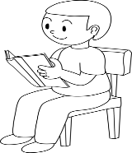
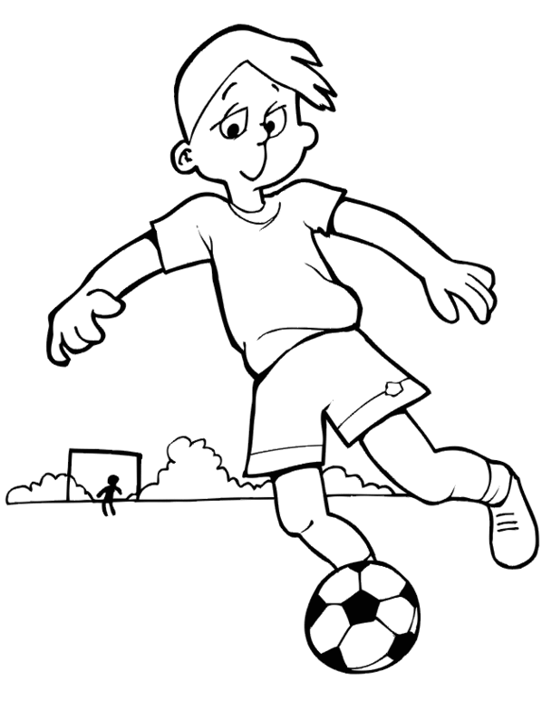
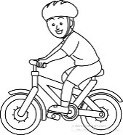

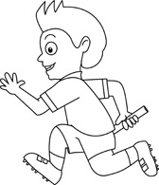
1
5
4
3
2

- Do you like running? Yes, I do. / No,I don't.
- Do you like painting? Yes, I do. / No,I don't.
- Do you like cycling? Yes, I do. / No,I don't.
- Do you like playing football? Yes, I do. / No,I don't.
- Do you like reading? Yes, I do. / No,I don't.

Question number four: What time is it? ( 5 marks)
It's half past four. | It's five o'clock. | It's three o'clock. | It's one o'clock. | It's half past ten.


